**Project Design Phase-II**

**Data Flow Diagram & User Stories**

|  |  |
| --- | --- |
| Date | 03 NOV 2023 |
| Team ID | NM2023TMID10680 |
| Project Name | Hashtag Generation |

**Data Flow Diagrams:**

A Data Flow Diagram (DFD) is a traditional visual representation of the information flows within a system. A neat and clear DFD can depict the right amount of the system requirement graphically. It shows how data enters and leaves the system, what changes the information, and where data is stored.

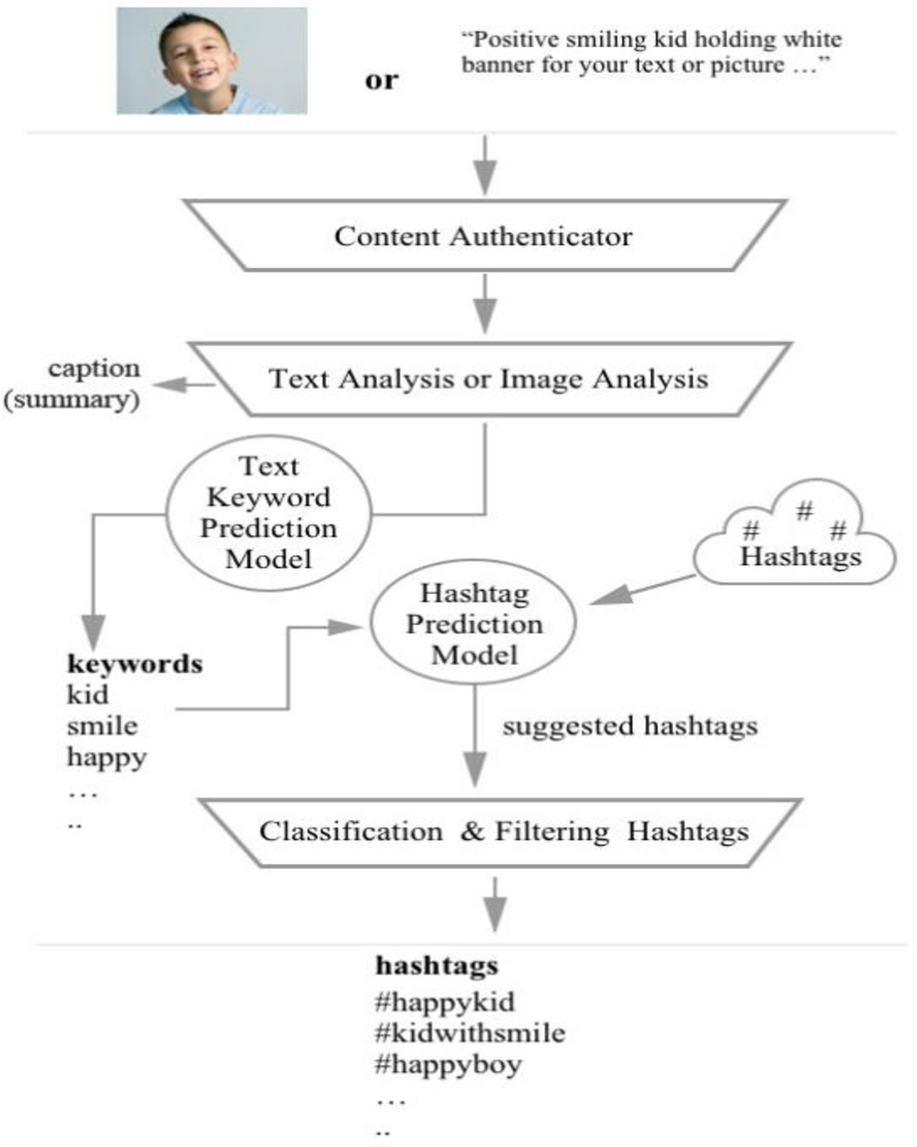**Example:** [**(Simplified)**](https://developer.ibm.com/patterns/visualize-unstructured-text/)

**User Stories**

Use the below template to list all the user stories for the product.

|  |  |  |  |  |  |  |
| --- | --- | --- | --- | --- | --- | --- |
| **User Type** | **Functional**  **Requirement**  **(Epic)** | **User Story Number** | **User Story / Task** | **Acceptance criteria** | **Priority** | **Team Member** |
| Customer | Registration | USN-1 | As a user, I want to input a piece of text or content into the system. | I can access my account / dashboard | High | Madhavan |
|  |  | USN-2 | As a user, I want the system to generate relevant hashtags based on the content I provide. | I can receive confirmation email & click confirm | High | Kapil |
|  |  | USN-3 | As a user, I want the ability to customize the generated hashtags by adding or removing specific ones. | I can register & access the dashboard with Facebook  Login | High | Badri Chelva |
|  |  | USN-4 | As a user, I want to see trending hashtags in real-time. |  | Medium | Hariprasad |
|  | Login | USN-5 | As a user, I want to view a history of previously generated hashtags. |  | Medium | Madhavan |
|  | Dashboard |  |  |  |  |  |
| Customer (Web user) |  |  |  |  |  |  |
| Customer Care Executive |  |  |  |  |  |  |
| Administrator |  |  |  |  |  |  |
|  |  |  |  |  |  |  |
|  |  |  |  |  |  |  |
|  |  |  |  |  |  |  |